**TITLE OF THE EXTENDED ABSTRACT**

Author1 A.B.¹, Author2 C.D.², *

¹ Affiliation One  
² Affiliation Two

Email of Corresponding Author: example@seu.ac.lk

# ABSTRACT (Times New Roman, Bold, Uppercase, Justified, Font Size: 10): First line should start here. (Times New Roman, Sentence Case, Font Size: 10, Single Line Spacing, Justified) (Maximum: 300 words). The abstract should be written as a single paragraph, and should not contain any references. It should outline objectives and methodology together with important results and conclusions.

# Keywords (Bold, Title Case, Font Size: 10, Justified): Definition, Project, Project Management (Times New Roman, Sentence Case, Font Size: 10, Single Line Spacing, Justified) (Maximum: 5 keywords)

# INTRODUCTION (TIMES NEW ROMAN, BOLD, UPPERCASE, FONT SIZE: 11)

# The first paragraph should start here. (Body Text: Times New Roman, Sentence Case, Font Size: 11, Justified, Line Spacing:1.15).

# This should state the reasons for performing the work with a brief review of related research studies in the context of the work described in the paper. Objectives of the study should be clearly stated.

**METHODOLOGY (TIMES NEW ROMAN, BOLD, UPPERCASE, FONT SIZE: 11)**

# First paragraph should start here. (Times New Roman, Sentence Case, Font Size: 11, Justified, Line Spacing: 1.15)

Methods can be mentioned with appropriate references. Methods of statistical analyses used need to be mentioned where relevant.

**RESULTS AND DISCUSSION (TIMES NEW ROMAN, BOLD, UPPERCASE, FONT SIZE: 11)**

Present your findings and explain them.

**Table 1. Sample Table Caption (Times New Roman, Title Case, Font Size: 10, Justified)**

|  |  |  |
| --- | --- | --- |
| Header 1 | Header 2 | Header 3 |
| Item 1 | Data 2 | Data 3 |
| Item 2 |  |  |

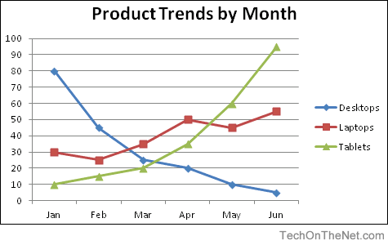

**Figure 1. Sample Figure Caption (Times New Roman, Sentence Case, Font Size: 11, Justified, Line Spacing: 1.15)**

Results: Results have to be concisely and logically presented. Discussion: Data essential for the conclusions emerging from the study need to be discussed.

**CONCLUSION (TIMES NEW ROMAN, BOLD, UPPERCASE, FONT SIZE: 11) (Times New Roman, Sentence Case, Font Size: 11, Justified, Line Spacing: 1.15)**

Summarize key results, limitations, and future research directions.

The conclusion should be brief, highlight the outcomes of the study and should be aligned with the objectives of the study.

**REFERENCES (TIMES NEW ROMAN, BOLD, UPPERCASE, FONT SIZE: 11)**

All research work of the authors, when used or referred to or cited, should be correctly acknowledged in the text and in the references.

Citing references in the text: References must be indicated in the text as per the Author Year system, by the author’s last name and year, in parenthesis (Able, 1997) or (Able and Thompson, 1998) or (Able et al., 1997)

The list of references should be arranged in alphabetical order based on the last name of the first author (List of references: APA referencing style, Times New Roman, Sentence Case, Font Size: 11, Justified, Line Spacing: 1.15).

Perera A.B., Fernando C.D. Title. Journal Name. Year, Volume(Issue), Pages.  
Perera, A. B., & Fernando, C. D. (2021). Title. Journal Name, 23(2), 123–130.

The APA style is an author-date referencing system which draws upon the 6th edition of the publication manual of the American Psychological Association (APA).